Lab Sheet: 2
Objective:
• To understand and implement SQL transactions using COMMIT, SAVEPOINT, and ROLLBACK, retrieve records using SELECT queries, and perform INSERT, UPDATE, and ALTER operations on tables.
Instructions:
- Open your preferred Database Management System (DBMS) tool.
- Create the required tables: CLASS, EMPLOYEES, andClient_master.
- Insert the given/suitable records into each table.
- Execute the SQL scripts and queries step by step.
- Observe the output carefully after each operation, especiallyafter ROLLBACK and UPDATE commands.
Table Structures:
CLASS
D (NUMBER) and Name (VARCHAR).
The initial records in the table are (1, 'Bravo'), (2, 'Alex'), and (4, 'Cheng').
EMPLOYEES
Employee_Id (NUMBER), First_Name (VARCHAR), Last_Name
(VARCHAR), Email (VARCHAR), Phone_Number (VARCHAR),
Hire_Date (DATE), Job_Id (VARCHAR), Salary (NUMBER), Commission_Pct (NUMBER), Manager_Id (NUMBER), and Department_Id (NUMBER).
DDL Questions (Data Definition Language):
- How do you create a table named CLASS with appropriate datatypes?
- How do you create a table named EMPLOYEES with thespecified attributes?
- How do you create a table named Client_master with thespecified attributes?
- What SQL statement would you use to rename the tableClient_master to Client12?
- How do you display the bal_due column heading as“BALANCE”?
DML Questions (Data Manipulation Language):
Part A: Transactions and Savepoints (CLASS Table) Give the output of the following SQL script:
    - INSERT INTO class VALUES (5,’Rahul’);
    - COMMIT;
    - UPDATE class SET name = ‘Abhijeet’ WHERE id=’5’;
    - SAVEPOINT A;
    - INSERT INTO class VALUES (6,’Chris’); o SAVEPOINT B; o INSERT INTO class VALUES (7,’Bravo’);
    - SAVEPOINT C; o SELECT * FROM class; o ROLLBACK TO B; o SELECT * FROM class; o ROLLBACK TO A;
Part B: Retrieving Records (EMPLOYEES Table)
  - Find out the employee id, names, and salaries of all theemployees.
  - List out the employees who work under manager 100.
  - Find the names of the employees who have a salary greaterthan or equal to 4800.
  - List out the employees whose last name is ‘AUSTIN’.
  - Find the names of the employees who work in departments60, 70, and 80.
  - Display the unique Manager_Id.
Part C: Updating Records (Client_master Table)
  - Insert five records into the Client_master table.
  - Find the names of clients whose bal_due > 5000.
  - Change the bal_due of ClientNO "C123" to Rs. 5100.

ANSWERS
DDL QUESTIONS:
Q1. How do you create a table named CLASS with appropriate data types?
CREATE TABLE CLASS (
Id NUMBER PRIMARY KEY,
Name VARCHAR2(50)
);
Insert initial records:
INSERT INTO CLASS VALUES (1,'Bravo'); INSERT INTO CLASS VALUES (2,'Alex');
INSERT INTO CLASS VALUES (4,'Cheng');
COMMIT;
Q2. How do you create a table named EMPLOYEES with the specified attributes?
CREATE TABLE EMPLOYEES (
Employee_Id NUMBER PRIMARY KEY,
First_Name VARCHAR2(50),
Last_Name VARCHAR2(50),
Email VARCHAR2(100),
Phone_Number VARCHAR2(20),
Hire_Date DATE,
Job_Id VARCHAR2(20),
Salary NUMBER(10,2),
Commission_Pct NUMBER(5,2),
Manager_Id NUMBER,
Department_Id NUMBER
);
Q3. How do you create a table named Client_master with the specified attributes?
CREATE TABLE Client_master (
ClientNo VARCHAR2(10) PRIMARY KEY,
Name VARCHAR2(50),
City VARCHAR2(50),
Pincode NUMBER,
State VARCHAR2(50),
Bal_due NUMBER(10,2)
);
Q4. What SQL statement would you use to rename the table Client_master to Client12?
RENAME Client_master TO Client12;
Q5. How do you display the bal_due column heading as “BALANCE”?
SELECT Bal_due AS "BALANCE"
FROM Client_master;
DML QUESTIONS:
PART A: Transactions and Savepoints (CLASS Table)
CREATE DATABASE IF NOT EXISTS DBMS_Lab2_PartA;
USE DBMS_Lab2_PartA;
DROP TABLE IF EXISTS CLASS;
CREATE TABLE CLASS (
Id INT PRIMARY KEY,
Name VARCHAR(50)
);
INSERT INTO CLASS VALUES (1,'Bravo'); INSERT INTO CLASS VALUES (2,'Alex');
INSERT INTO CLASS VALUES (4,'Cheng');
COMMIT;
SET autocommit = 0;
INSERT INTO CLASS VALUES (5,'Rahul');
COMMIT;
UPDATE CLASS SET Name='Abhijeet' WHERE Id=5;
SAVEPOINT A;
INSERT INTO CLASS VALUES (6,'Chris'); SAVEPOINT B;
INSERT INTO CLASS VALUES (7,'Bravo');
SAVEPOINT C;
SELECT 'After All Inserts (C)' AS Stage, Id, Name FROM CLASS;
ROLLBACK TO B;
SELECT 'After ROLLBACK TO B' AS Stage, Id, Name FROM CLASS;
ROLLBACK TO A;
SELECT 'After ROLLBACK TO A' AS Stage, Id, Name FROM CLASS;
COMMIT;
Output:
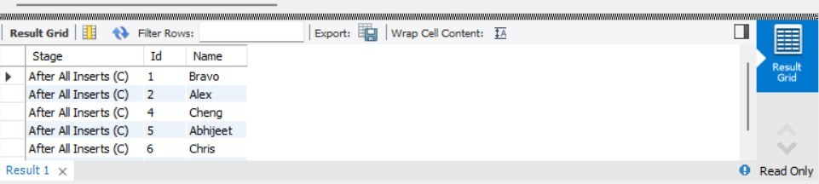
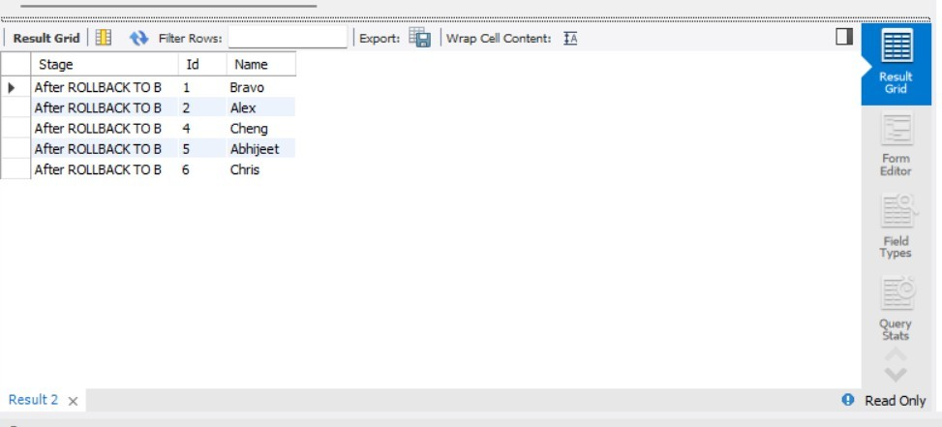
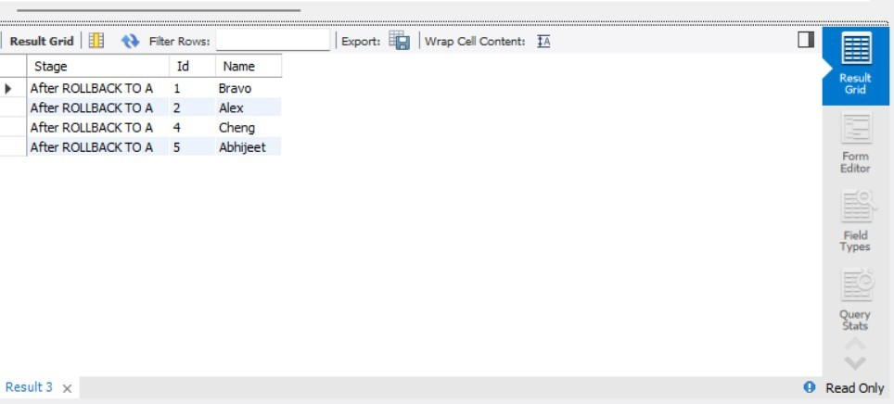
PART B – RETRIEVING RECORDS (EMPLOYEES Table)
CREATE DATABASE IF NOT EXISTS DBMS_Lab2_PartB;
USE DBMS_Lab2_PartB;
DROP TABLE IF EXISTS EMPLOYEES;
CREATE TABLE EMPLOYEES (
Employee_Id INT PRIMARY KEY,
First_Name VARCHAR(50),
Last_Name VARCHAR(50),
Email VARCHAR(100),
Phone_Number VARCHAR(20),
Hire_Date DATE,
Job_Id VARCHAR(20),
Salary DECIMAL(10,2),
Commission_Pct DECIMAL(5,2),
Manager_Id INT,
Department_Id INT
);
INSERT INTO EMPLOYEES VALUES
(101,'John','Austin','john@gmail.com','9999999999','2020-0110','IT_PROG',5000,NULL,100,60),
(102,'Neha','Sharma','neha@gmail.com','8888888888','2021-02-
15','HR_REP',4500,NULL,100,70),
(103,'Rahul','Verma','rahul@gmail.com','7777777777','2019-03-
20','IT_PROG',6000,NULL,101,80),
(104,'Anjali','AUSTIN','anjali@gmail.com','6666666666','2022-04-
12','SA_REP',4800,NULL,100,60);
COMMIT;
- Find out the employee id, names, and salaries of all the employees.
SELECT Employee_Id, First_Name, Last_Name, Salary FROM EMPLOYEES;
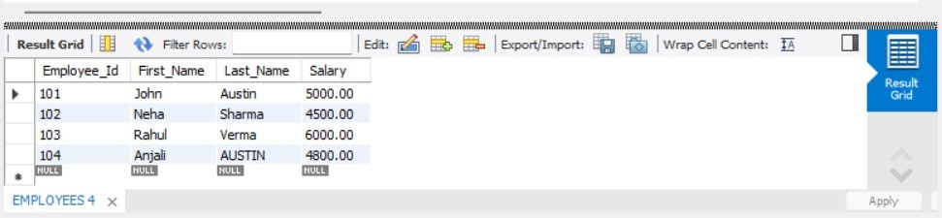
- List out the employees who work under manager 100.
SELECT First_Name, Last_Name FROM EMPLOYEES WHERE Manager_Id = 100;
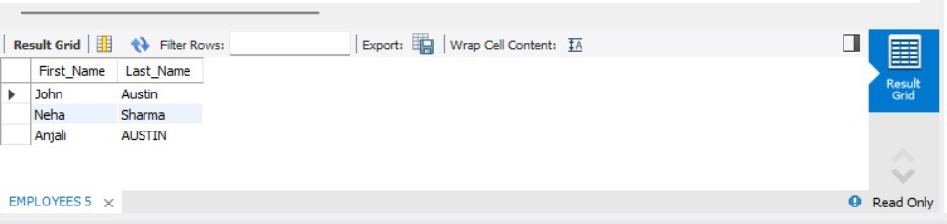
- Find the names of the employees who have a salary greater than or equal to 4800.
SELECT First_Name, Last_Name FROM EMPLOYEES WHERE Salary >= 4800;
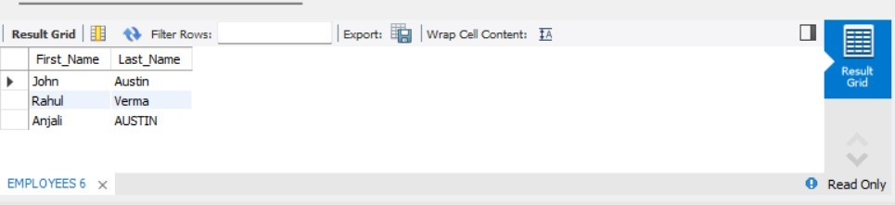
- List out the employees whose last name is ‘AUSTIN’.
- SELECT First_Name, Last_Name FROM EMPLOYEES WHERE Last_Name = 'AUSTIN';
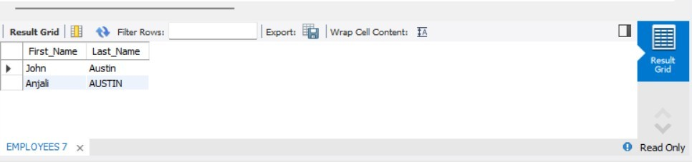
  - Find the names of the employees who work in departments 60, 70, and 80.
SELECT First_Name, Last_Name FROM EMPLOYEES WHERE Department_Id IN (60,70,80);
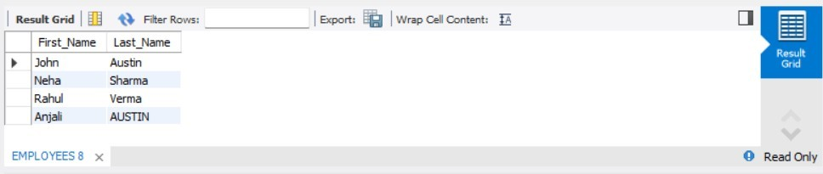
  - Display the unique Manager_Id. give for part b answers.
  - SELECT DISTINCT Manager_Id FROM EMPLOYEES;
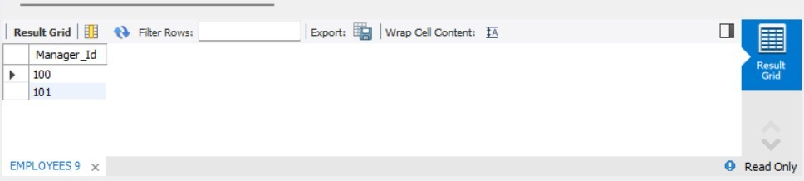
PART C – CLIENT_MASTERTABLE
CREATE DATABASE IF NOT EXISTS DBMS_Lab2_PartC;
USE DBMS_Lab2_PartC;
DROP TABLE IF EXISTS Client_master;
CREATE TABLE Client_master (
ClientNo VARCHAR(10) PRIMARY KEY,
Name VARCHAR(50),
City VARCHAR(50),
Pincode INT,
State VARCHAR(50),
Bal_due DECIMAL(10,2)
);
- Insert five records into the Client_master table.
INSERT INTO Client_master VALUES
('C123','Amit','Delhi',110001,'Delhi',5000),
('C124','Neha','Mumbai',400001,'Maharashtra',8000),
('C125','Rahul','Chennai',600001,'Tamil Nadu',3000),
('C126','Sneha','Kolkata',700001,'West Bengal',9000), ('C127','Kiran','Bangalore',560001,'Karnataka',2000);
COMMIT;
- Find the names of clients whose bal_due > 5000.
SELECT Name, Bal_due FROM Client_master WHERE Bal_due > 5000;
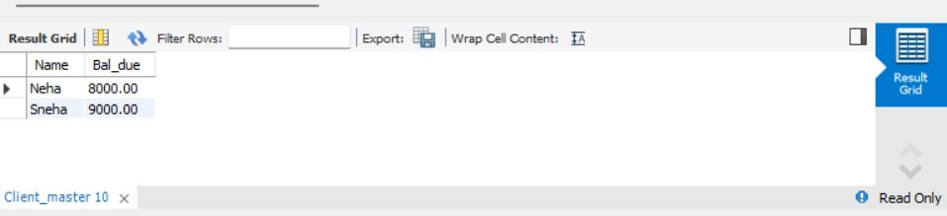
- Change the bal_due of ClientNO "C123" to Rs. 5100. gave answers for part c.
UPDATE Client_master SET Bal_due = 5100 WHERE ClientNo = 'C123';
COMMIT;
SELECT * FROM Client_master;
